**Documentation for national jobs portal website**

**Introduction:**

National jobs portal web is basically a website for searching jobs and applying for jobs at national level. This web provides the facility to search and apply for a government job through this portal. We can also upload our resume or cv and wait for the response from the portal or organization. It has different fields of interest in which almost every skilled person in Pakistan can apply for jobs. And land their dream job. User can also create an account for log in and check for applied job or apply for a job and upload your resume or cv.

**Problem statement:**

We have to analyze this website and target the changes in color scheme, understandability and how to make it easy to use for the user. So, it has some changes in its design and color pattern which can be made to make it better for users of every age group to understand it.

**Solution:**

After analyzing the website. The changes in design and color pattern are carried out as this design has some flaws and minor changes can be done to make it much better and more understandable.

**More understandable:**

Make menu of the web clearer and more visible for all the users. Which shows the purpose of everything in menu of the website. And make the interface more user friendly by using a well-organized layout. A much better understanding can be made for the user by using the bigger icons to guide the user for his purpose. And also using images for better understanding of user. Also to add the help section or FAQ for basic queries of user. So, user can have better understanding to apply for the job. Lanaguage must be kept simple and also use different or more than one language or have the option of selecting language for user to make it easy to understand.

**Eye-catching Design:**

By improving the typography which means more appealing text should be added in the website which can provide better readability. By using more appealing button fonts and designs for the apply job. Add a dashboard with more interactive graphics which shows the job results of users as they have landed a job or how many they have applied to and other details of the applicant. A testimonial carousel which shows the success rate of all the applicants who have successfully landed a job. Instead of a map pic a real map to be integrated highlighting job locations and companies.

**Easy to use:**

We will use cleaner layout which clearly shows the labels and buttons more clearly. In testing process, we will make sure that website portal works efficiently on different devices. User can adjust size of text as required and also adding text to speech for making it easy to use. Provide a video section by which anyone can see how to use the portal. Have a feedback form in the website which can be used to get proper feedback from users of website so new changes can be considered for improving the portal.

**Better color scheme:**

Analyzing the present color scheme, it should be replaced with blue shades of blue and with some shades of green also which can be used in buttons and pop-ups. Will use the contrast between the text and the background and use light background with blue color so text will be visible. All pages should be having the same color scheme to maintain the consistency in the design.

**New feature suggestions:**

* Adding new categories like remote jobs and jobs with salary range.
* Feedback system from the user so job employers can make the changes to their hiring process.
* Update the user in the dashboard or have an alert msg for job notification for keeping the user updated on the relevant jobs.
* A new section added for user to get prepared for jobs or have about the career being chosen
* It should be better to have a mobile application to provide user with better experience
* A chat bot has been added but a live chat support will be better to be communicated with when user have more than the basic queries.

**SDLC national job portal:**

SDLC for the NJS consist of the following:

**Planning:**

Planning phase consist if requirement gathering about the NJS portal from the user’s which can be employes, employers and companies itself so all the information should be gathered from them as it’s the most important phase in the SDLC. Resources and time should also be allocated to the project in this phase.

**Analysis:**

**Functional requirements:**

* User management (user can be employe, employers, companies itself)
* Profile management for employes they can change their profile data according to their desired job and edit their uploaded resume.
* Job management employers can edit the job vacancies according to the company requirements.
* Notification or communication about the new job posting or updates about the jobs.
* Review and feedback system
* Admin panel for managing the job postings and for managing reports on site usage
* Keeping the user data secure by encrypting the user data and restrict access to sensitive or personal data.

**Non-functional requirements:**

* Performance of the website should be better as it should respond in 5 seconds.
* A good number of users should be able to handled up by the website concurrently.
* Usability of website depends on the interface as its easy to use for the user regardless of the age groups of the users any age group should be able to use it easily.
* Security of the data should be through encryption.
* Reliability in the sense of quick backups or in case of any failures.
* Maintainability depends upon the clean code of the website so it can be easy to reuse for maintenance purpose.

**Use case diagram:**

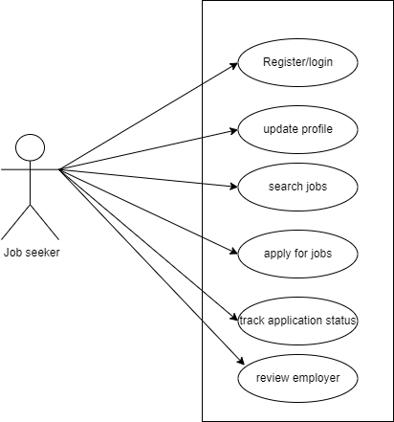

Figure 1 Use case 1

This use case diagram shows the relation between the job seeker as a user and all the use cases or functionalities which can be performed by the job seeker in this website

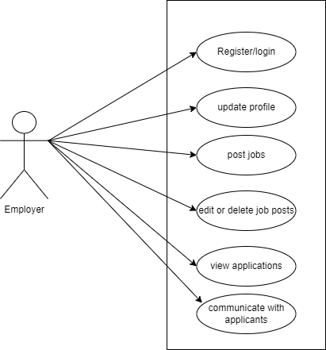

Figure 2 Use case 2

This use case diagram shows the relation between the employer as a user and all the use cases or functionalities which can be performed by the employer in this website

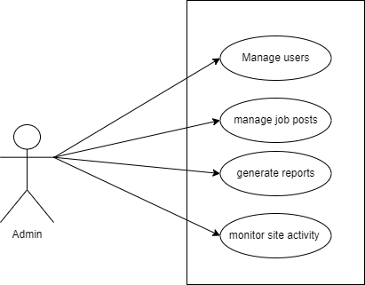

Figure 3 Use case 3

This use case diagram shows the relation between the admin as a user and all the use cases or functionalities which can be performed by the admin in this website

**Design:**

**System architecture:**

**Hardware components**

* Pc core i3
* RAM minimum 32 GB
* SSD storage minimum 1TB
* High speed internet connection

**Software components**

* Database (MY SQL)
* Language html, CSS, php
* SSL certificate/ firewall
* Windows 8,10 and 11

**ERD (Entity relationship diagram):**

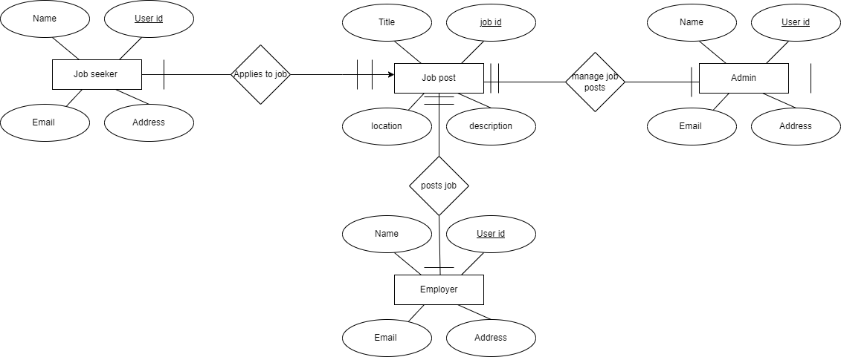

Figure 4 ERD Diagram

**Conclusion:**

The National Jobs Portal (NJP) website has been designed to serve as a comprehensive platform for job seekers and employers. With a user-friendly interface, it ensures ease of use across different age groups. The incorporation of modern HTML and CSS for frontend design, alongside PHP for backend functionality, provides a robust structure. The addition of key features such as job listings, search functionality, and user applications enhances its practicality. The responsive design and aesthetic improvements, including background images and well-aligned content, contribute to a visually appealing and effective job portal.